

Endeavour Health Charitable Trust in partnership with Leeds Teaching Hospital Trust and Leeds University

RESOLUTION – LEEDS

Leeds CF Project – Data Service Architecture

Version 1.1

Draft

**Amendment History**

|  |  |  |
| --- | --- | --- |
| Version | Date | Amendment History |
| 1.0 | 19/1/2015 | Initial draft |
| 1.1 | 26/1/2015 | Removal of hardware spec. Update of architecture diagram fig 2 |
|  |  |  |

**Authors and Reviewers**

This document must be reviewed by the following:

|  |  |  |  |
| --- | --- | --- | --- |
| Name | Title / Responsibility | Date | Version |
| David Stables | Trustee , Endeavour Health | 19/1/2015 | 1.0 |
| Dr Daniel Peckham | Consultation Leeds Teaching hospital Trust |  |  |
| Jonathan Homer | Project Architect – Endeavour Health |  |  |

**Approval**

This document must be approved by the following:

|  |  |  |  |
| --- | --- | --- | --- |
| Name | Title / Responsibility | Date | Version |
|  |  |  |  |
|  |  |  |  |

Contents

1 Background 4

1.1 Funding and resource 4

1.2 Scope of project 5

1.3 Scope of this document 5

2 Architecture 5

2.1 Resolution and Discovery 5

2.2 Data flows 6

2.3 Technical architecture 8

2.3.1 Components and connectivity between them 8

2.3.2 EMIS Web Integration 10

2.3.3 VitruCare Integration 12

2.3.4 Prescribing Workflow Application Integration 12

2.3.5 Data Analytics Service Integration 12

2.3.6 Hardware and software Technologies 13

3 Service Support 14

# Background

The University of Leeds and Leeds Teaching Hospital NHS Trust, the University of Leeds and the Endeavour Health charitable trust have formed a collaboration to undertake a project known as “The Leeds’ patient orientated IT benefit evaluation project”.

The aim of phase 2 of this project is to empower patients, support medication adherence, and improved decision making through improved electronic communication and access to relevant clinical information.

The primary initial focus will be on medication management. The rationale for phase 2 is as follows:

Allowing patients to maintain accurate live medication lists is an essential part of care. Patients with CF are usually taking numerous and diverse types of medications which are frequently changing. Knowledge about indications and adverse effects is often limited or not retained, and poor adherence results in unnecessary and premature decline in health.

The linking of data in the various prescribing systems will allow accurate audit of pick up rates and trigger patient reminders. Adherence feedback, reports, alarms would reduce error. Linking such data with secondary care health care professionals would allow prescribers to adjust treatment according to both patient need and trigger patient education and support to individuals struggling with treatment.

This phase of the project will provide a communication link between the professionals providing care and the patient at home, focusing initially on the management of medicines, including the home delivery service. This will enable automated data flows between the CF unit clinicians and nurses, the CF unit pharmacist, the hospital pharmacist, the patient, and the patient’s GP.

In addition to medication data flows, clinical data such as weight, body mass index, forced expiratory volume, exacerbations, intravenous antibiotics, pathology results (e.g. CRP, HbA1c) will inform patients of clinical outcome. Coded data such as flu vaccination, bacterial isolates and annual assessments will provide additional intelligence and rules.

The sharing of data will enable computerised decision support to operate more effectively. Examples include triggering eradication protocols, reminder about booking investigations and allowing patients to book clinics according to sputum bacterial isolates. Elevation in parameters such as CRP and HbA1c would inform the patient of disease progression and trigger alerts and management advice directly to the patient.

## Funding and resource

Endeavour Health Charitable Trust is funding the project.

Dr Daniel Peckham is project lead and owner responsible for informing the design, functional requirements and project delivery.

Endeavour is also responsible for providing some of the development resource to support the successful delivery of the project and provides the service delivery for the pilot.

The Leeds Trust owns the service and provides information governance.

AIMES Liverpool provides the secure hosting environment.

Dynamic Health Systems provides the patient application known as Vitru care.

EMIS provides the unit’s clinical management system known as EMIS Web and the Interfaces to it.

## Scope of project

The project is a pilot using pre-selected patients currently receiving treatment from within the Adult Cystic Fibrosis (CF) unit at Leeds. The Trust and the University will collaborate to manage the patient recruitment process.

Initial communication scope will be limited to a simple digital workflow between the hospital pharmacists, and the patient. If successful, future phases will see the inclusion of the Homecare delivery suppliers integrating with the JAC prescribing management solution in use at the Trust, as well as a link to the GP records within primary care.

## Scope of this document

The scope of this document covers the data flows and software hosting architecture. These come together as an integration service which is referred to as “Resolution” (Leeds).

Part of the project involves hosting of patient identifiable data under the data control of the Leeds Trust. A service is in place that stores the data and provides access to it. This part of the service is referred to as “Discovery”.

*N.B Neither Resolution nor Discovery are brand or a product names as such and is used as a means of categorization of this element of the project*

The Resolution (integration) service uses the Discovery (data access) service as part of the project in the ways described below. The separation is to make sure that as time goes on there is no interdependency between care record data store and the integration service. For example, the Leeds Care Record may be the data store for the record rather than the Discovery data store.

# Architecture

## Resolution and Discovery

Resolution is a message brokering service that receives data transmitted from any of the end “publisher” systems and transmits the data to the relevant “subscriber” systems. Systems may be both publisher and subscriber.

Data exchange may consist of:

1. Changes to a record in one system that may be relevant to a record in a subscriber system, and permissions exist for that data to be exchanged
2. Communication messages between one user and another (health professional or patient) for managing medications or other aspects of their care.

Data Distribution Protocols manage the flows. A Data Distribution Protocol is a set computable routing rules based on the data sharing agreements that cover:

1. Who can send to who for which business purpose
2. What data they can send for the above purpose

Patient consent settings further limit the flow of data. Resolution includes a permissions service, which uses patient consent settings to determine whether the data can flow into or out of the data control domain of the Trust.

Resolution is also responsible for message validation, message transformation and acknowledgement management.

Record data received by the Resolution will be persisted in the Discovery data repository in an open standard format. The data repository organizes the data in a person oriented manner i.e. is keyed by the patient identifier. In addition, the data entries are stamped with the data controller identifier so that each entry in the record can be clearly attributed to the data controller.

All messages are sent to the Service over a secure transport layer on the N3 network. Message data will be persisted in Resolution for the purposes of resilience, error handling, and audit. The message data within Resolution remains under the control of the publisher.

A comprehensive service dashboard is available to configure and monitor the health status of the Service.

## Data flows

**Figure 1** illustrates the data flows supported by Resolution in this project. It also illustrates the boundaries of service ownership and data controller:

**Figure 1 Initial data flows, data controllers and service owners**



The following scenarios illustrate some of the data flows:

**Scenario 1 – Clinician Medication prescribing.**

“As a Doctor I want information relating to a new drug that I issue in EMIS Web as a 'Repeat' item to be sent automatically to the pharmacy module so that the drug can be processed by the specialist pharmacist.”

The data flows as follows:

EMIS WEB -> Resolution ->Pharmacy app

->EHR store

->Analysis database

**Scenario 2 – Patient medication ordering**

**“**As a Patient I want to order a repeat of one or more items of my current medication via my Mobile App so that I can comply with my medication regimen”

VITRU Care -> Resolution ->Pharmacy app

->Discovery EHR Store

**Scenario 3 – Patient record management**

“As a Patient I want to view the care information that relates to my condition, including the information I have entered about myself and the information that has been entered by my doctor, so that I can keep up to date with the most recent information on my condition and treatments”

EMIS Web ->Resolution ->Discovery EHR Store

Discovery EHR Store->Resolution->VITRU Care

To summarise, each scenario consists of data flows that generally flow from one source to two or more destinations either directly (as in Scenario 1 and 2) or indirectly via the EHR store.

*N.B It is important to recognise that there is a distinction between the application databases and the EHR store.*

->

## Technical architecture

### Components and connectivity between them

The following diagram (**Fig. 2)** shows a high-level project architectural overview.  The Resolution and Discovery Services section is the focus of this document.

**Figure 2 – Technical architecture overview**



In order to be able to make sense across a patch there does need to be a single software and hardware platform at the core. This platform will have three characteristics:

1. It uses a cloud computing model (or as close to that as the NHS allows) as the small number of interactions initially will rise exponentially.
2. Each of the components operate independently of each other so they can be replaced individually without major upgrade issues
3. The platform supports the emerging standards (such as REST and FHIR messaging) out of the box but enables legacy standards to co-exist.
4. All code is open source and free for copy, modification, and commercial exploitation.

The following diagram (**fig. 5)** illustrates a logical separation of the main hosted service components:

**Figure 6 – Logical separation of components**

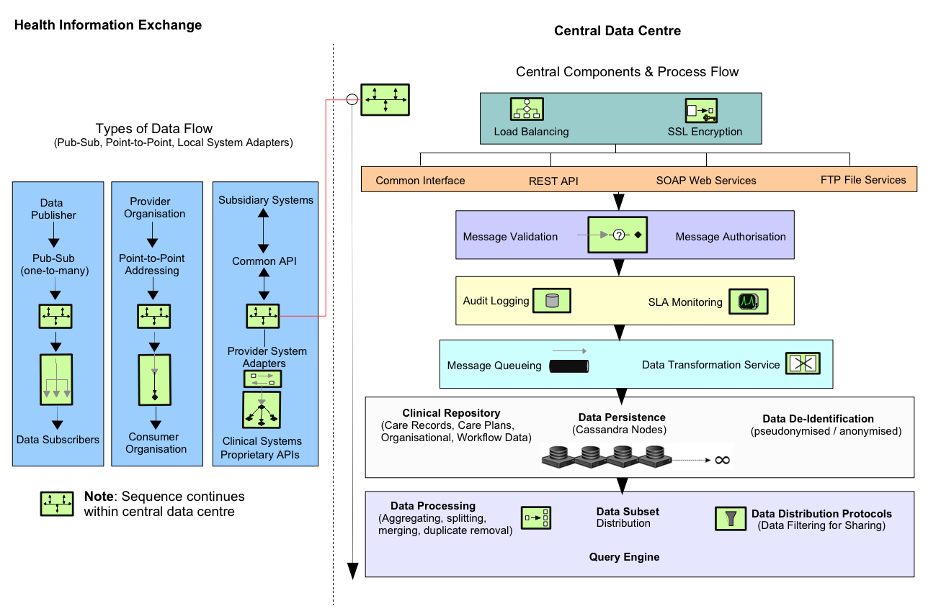

### EMIS Web Integration

Based on the project requirements to replicate data as near to real time as possible and the necessity to write data items back into the EMIS clinical system, the Patient Access API method is the most appropriate method of integration.

All interaction with the Patient Access API is co-ordinated by a locally deployed ‘API Integration Component’. This component has been developed as a Windows Service using the .NET framework (target version to be confirmed) and is based on the External Interface Specification provided by EMIS.

This component is responsible for extracting changed patient records from EMIS Web and publishing them to the Resolution Service. In addition, it also subscribes to changes made by the patient/pharmacy facing applications. These changes are pulled from the Service and stored in EMIS Web via the API.

The client scheduler polls the Patient Access API at regular intervals, requesting a list of patients that have received record updates since the previous request. A further API call is then made to extract the patient record for each of the identified patients. This record is then subsequently sent to the Resolution Service.

***NB***: Reducing the scheduled interval and therefore increasing the polling frequency of the API will also reduce the potential for stale records in the central repositories. However, reducing the polling interval by too much may result in negative performance implications within the EMIS infrastructure. Therefore, the scheduled interval will be configured in line with EMIS guidelines.

There is a requirement for data to be written back to the EMIS System, survey data collected from the patient, clinical and pharmacy teams will be fed back in a structured format. This will enable a communication layer with primary care to help inform patient adherence and any interactions with new medication regimes and treatments. Due to inbound firewall restrictions it is generally not possible to communicate directly with the client component from the Resolution Service. The use of a ‘WebSockets’ style technology should be utilised to enable bi-directional communication between the client and server allowing update notifications to be sent directly to the client.

The following EMIS Patient Access API methods will be used by the solution:

* Get Patient Sequence (initial bulking).
* Get Changed Patients
* Get Changed Patients Medical Record
* Get Medical Record
* File Record

Further details of the API definitions can be found in the latest version of the EMIS Partner Programme documentation.

The following flow diagrams illustrate the typical API interfaces use within the solution.

*Figure 3* shows the identification of patients with changed records in EMIS Web and the publishing of the updated medical records to the Data Service.

**Figure 3 EMIS API for publishing data**



Figure 2 Publish EMIS Web Changes Data Flow

*Figure 4* shows the retrieval of changes made to the central repository and subsequent filing into EMIS Web via the API.

**Figure 4 Sending data to EMIS Web**



Figure 3 File Central Changes in EMIS Web Data Flow

### VitruCare Integration

Details of VitruCare integration can be found in the following document:

‘VitruCare clinical system integration specification 2013-10-15.docx’.

### Prescribing Workflow Application Integration

TBC.

### Data Analytics Service Integration

TBC

### Hardware and software Technologies

The service is designed for scalability and resilience, eliminating any single points of failure and encompassing automatic failover. The following open source technologies are used:

#### Development Tools

* Java8
* Javascript/JQuery
* Maven (build automation tool)
* Spring 4 (Core support for dependency injection, transaction  management, web applications, data access, messaging, testing)
* IntelliJ (Development IDE)
* GitHub (web-based repository for revision control and source code  management)

#### Database

Apache Cassandra  - version 2.2.2

Key Features of Cassandra:

* Elastic scalability
* Always on architecture
* Fast linear-scale performance
* Flexible data storage
* Easy data distribution
* Operational simplicity
* Transaction support

#### Server Technologies

* Apache Tomcat 8 (open-source web server)
* Apache Camel 2.15 (rule-based routing and mediation engine that provides a  Java object-based implementation of the Enterprise Integration Patterns  using an API)
* Java SE 8
* Linux Ubuntu 12.04 or above

#### Messaging Queuing

**RabbitMQ – version 3.5.6**

Key Features of RabbitMQ:

* Reliability
* Flexible Routing
* Clustering
* High availability queues
* Multi-protocol
* Management UI
* Tracing

#### APIs and Protocols

* REST
* SOAP
* SFTP

#### Data Standards and Transforms

* IHTSDO SMOMED CT
* FHIR
* ITK
* XML
* JSON
* EMISOPEN

# Service Support

Endeavour technical team and AIMES hosting team provide pilot support.

Endeavour technical team provide user support and software support.

AIMES hosting team provide support for the hosting service and operate through Endeavour for the pilot.

Hours of support are 9 am to 5 pm, 5 days a week.

Private key SSH console based access will be required.

Endeavour will produce administration and monitoring tools to assist the on-going support of the products.

All component patching and deployment will be planned and scheduled.

The system is configured in such a way that multiple versions of software are supported to provide minimum disruption to the interoperability of components.